**1: Import the dataset and do usual exploratory analysis steps like checking the structure & characteristics of the dataset:**

**1: Data type of all columns in the "customers" table.**

**Query:**

SELECT

column_name,

data_type

FROM

`spry-shade-390404.Target.INFORMATION_SCHEMA.COLUMNS`

WHERE

table_name = 'customers';

**SS:**

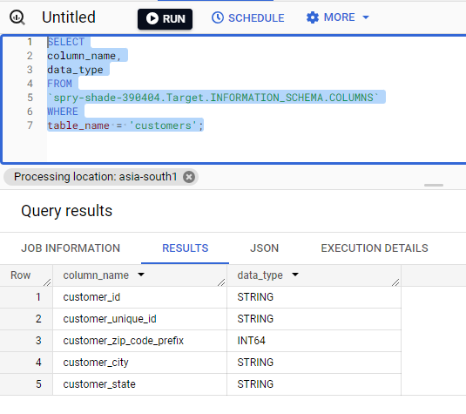

**INSIGHT**: It helps us to understand the structure and characteristics of the data type and columns stored in the provided "customers" table.

**RECOMMENDATION**: Based on the above query it is helpful to validate the data type in the particular column. For example numeric data should be as **INTERGER/FLOAT** and text as **VARCHAR/STRING**.

**2.Get the time range between which the orders were placed.**

**Query:**

select min(order_purchase_timestamp) as start_ordertime,

max(order_purchase_timestamp) as  end_ordertime

from `Target.orders`;

SS:

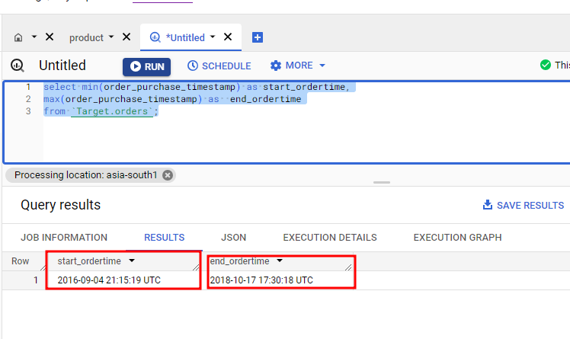

**INSIGHT:** This SQL query retrieves the start time & end time where the order placed in the provided time period by using minimum and maximum values of the "order_purchase_timestamp" column from the "orders" table.

**RECOMMENDATION:** Time-series analysis can help identify seasonal fluctuations, peak periods, or any significant changes in customer behavior. Also helps marketing strategies, and overall business planning.  
  
**ASSUMPTION:** Assumption made here is that the SQL query provided is correctly the max.min order purchase time stamp**.**

**3.Count the Cities & States of customers who ordered during the given period.**

**Query:**

SELECT cus.customer_city,cus.customer_state,COUNT(ord.customer_id) order_count

FROM

  `Target.customers` cus

JOIN `Target.orders` ord

on cus.customer_id = ord.customer_id

GROUP BY cus.customer_city,cus.customer_state

ORDER BY order_count DESC

**SS:**

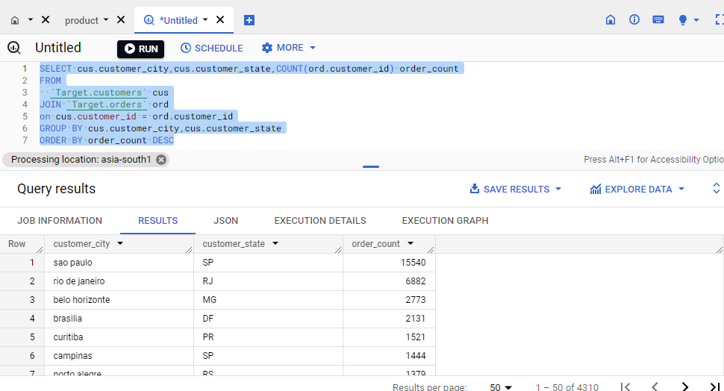

**INSIGHT:** It helps us to understand the distribution of count of orders across different cities and states were done in the provided given period.  
  
**RECOMMENDATION:** This analysis can provide the valuable insights like where the most of orders comes from particular cities or states in the regions, by using this we can target accordingly in future plans or strategies and we can easily understand where the company has a significant customer base and sales are most concentrated.  
  
**ASSUMPTION:** Assumption made here is that the state **SP** have received more counts of orders from the customers and followed by the states **RJ,MG,DF**

**2: In-depth Exploration:**

1. Is there a growing trend in the no. of orders placed over the past years?

**Query:**

SELECT

EXTRACT(YEAR FROM ord.order_purchase_timestamp) AS year,

EXTRACT(MONTH FROM ord.order_purchase_timestamp) AS month,

COUNT(DISTINCT ord.order_id) AS order_count

FROM

`Target.orders`ord

JOIN `Target.customers`cus ON

ord.customer_id = cus.customer_id

GROUP BY year,month

ORDER BY year,month

SS:

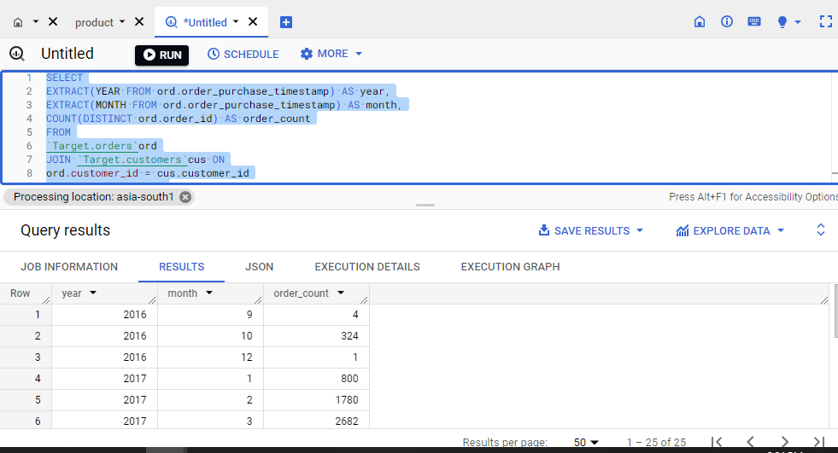

**INSIGHT:** This SQL query helps us to understand the trends of orders placed in each month and year, by using we can observe the increasing trends in the year over year.  
  
**RECOMMENDATION:** Identifying a growing trend that indicate the company's increasing popularity and potential for future growth, and good signs for us.  
  
**ASSUMPTION:** Assumption made here is that based on the output there is increase on trending growth based on 2016/2017. So, it leads to give us a conclusion that we created a good customer base

**2.Can we see some kind of monthly seasonality in terms of the no. of orders being placed?**

**Query:**

SELECT

extract(month from order_purchase_timestamp) as Month,

COUNT(order_id) as Total_Orders_in_Month

FROM `Target.orders`

GROUP BY Month

order by Month;

SS:

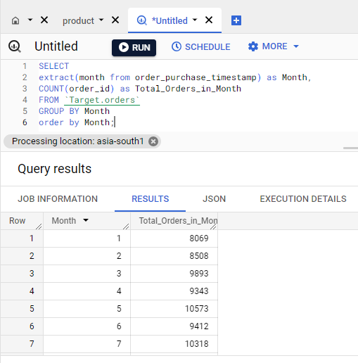

**INSIGHT:** It helps us to calculates the count of orders placed in each month, allowing us to observe the potential of each and every month and seasonality in the number of orders in the respective months  
  
**RECOMMENDATION:** It to visualize the data using seasonality in the number of orders over the months and we can conclude like in which month we receive more number of orders by using the we can target that specific month with huge budget for marketing, it give us a good result.  
  
**ASSUMPTION:** Assumption made here is during that month **May, July, August** month the orders are getting increased due to some seasonality change on **BRAZIL**

**3.During what time of the day, do the Brazilian customers mostly place their orders? (Dawn, Morning, Afternoon or Night)**

* + 1. **0-6 hrs : Dawn**
    2. **7-12 hrs : Mornings**
    3. **13-18 hrs : Afternoon**
    4. **19-23 hrs : Night**

**Query:**

SELECT

CASE

when extract(HOUR from ord.order_purchase_timestamp) between 0 and 5 then 'Dawn'

when extract(HOUR from ord.order_purchase_timestamp) between 6 and 11 then 'Morning'

when extract(HOUR from ord.order_purchase_timestamp) between 12 and 17 then 'Afternoon'

when extract(HOUR from ord.order_purchase_timestamp) between 18 and 23 then 'Night'

END AS hour,

COUNT(ord.order_id) AS order_count

FROM

`Target.orders` ord

JOIN

`Target.customers` cus

ON ord.customer_id =cus.customer_id

GROUP BY

  hour

ORDER BY

  order_count DESC;

SS:

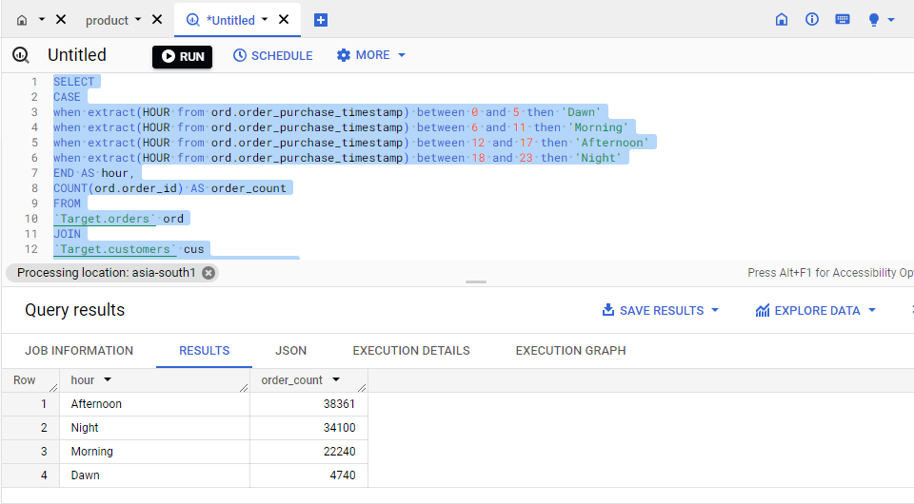

**INSIGHT:** In this SQL query we categorized the orders placed by Brazilian customers on the time of day they were made their respective orders in Dawn, Morning, Afternoon, or Night  
  
**RECOMMENDATION:** This analysis can provide valuable insights into the preferred time periods for placing orders by Brazilian customers. So it will helps us to find the peak time periods and we can target those peak times with special offers, discounts and increase ‘n’ number of orders.  
  
**ASSUMPTION:** Assumption made here is that during afternoon and night the BRAZILAIN people placing more orders

**3.Evolution of E-commerce orders in the Brazil region:**

**1.Get the month on month no. of orders placed in each state.**

**Query:**

SELECT

cus.customer_state,

EXTRACT(MONTH FROM ord.order_purchase_timestamp) AS month,

COUNT(DISTINCT ord.order_id) AS order_count

FROM `Target.customers` cus

JOIN `Target.orders`ord ON cus.customer_id=ord.customer_id

GROUP BY cus.customer_state,month

ORDER BY cus.customer_state,month

SS:

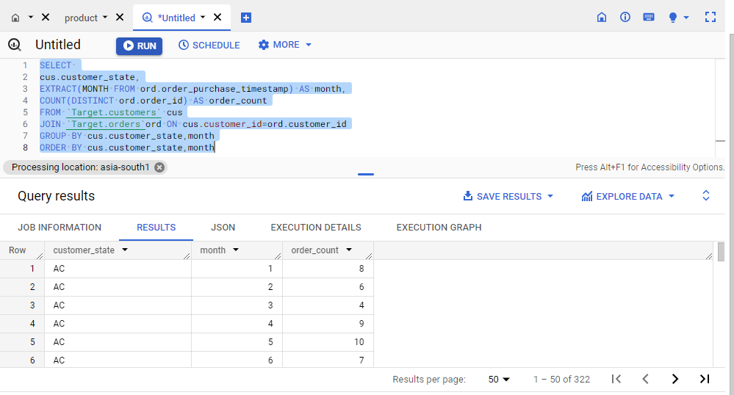

**INSIGHT:** This SQL query calculates the count of orders placed in each state of the Brazil customers on each & every month.  
  
**RECOMMENDATION:** This one gives us the insights called which month & from which state we were into the growth phase or down phase of our orders and then we can easily either increase the market budgets for the down fall one or completely exclude those.  
  
**ASSUMPTION:** It helps us to understand when and where the orders made will help to identify the market trend to take decision in marketing strategies.

**2.How are the customers distributed across all the states?**

**Query:**

select count(customer_id) as customer_count, customer_state

from `Target.customers`

group by customer_state

order by customer_count desc;

SS:

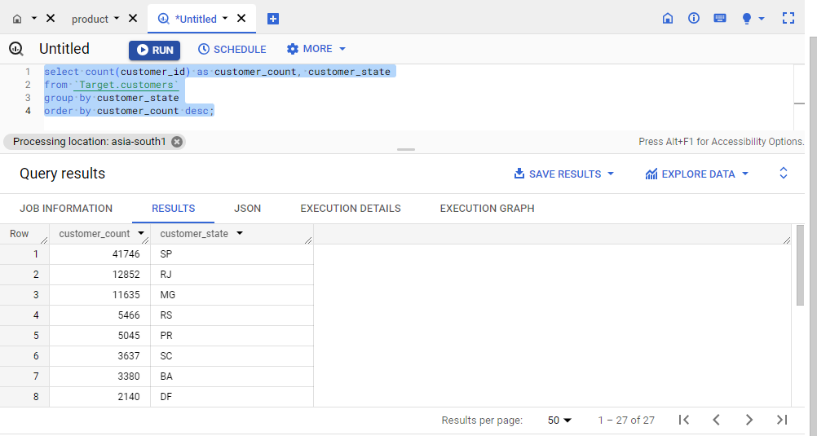

**INSIGHT:** It helps us to identify the count of customers distributed in each states  
  
**RECOMMENDATION:** This one made the marketing budgets and targeting strategies very easily like where we focus more or where we focus less because of how customers were distributed geographically and identify states with the highest customer strength.  
  
**ASSUMPTION:** It clearly gives that **SP, RJ and MG** have the most number of customers.

**4. Impact on Economy: Analyze the money movement by e-commerce by looking at order prices, freight and others.**

**1.Get the % increase in the cost of orders from year 2017 to 2018 (include months between Jan to Aug only).**

**You can use the "payment_value" column in the payments table to get the cost of orders.**

**Query:**

SELECT

EXTRACT(MONTH FROM o.order_purchase_timestamp) AS month,

(

(

SUM(CASE WHEN EXTRACT(YEAR FROM o.order_purchase_timestamp) = 2018 AND

EXTRACT(MONTH FROM o.order_purchase_timestamp) BETWEEN 1 AND 8 THEN

p.payment_value END)-

SUM(CASE WHEN EXTRACT(YEAR FROM o.order_purchase_timestamp) = 2017 AND

EXTRACT(MONTH FROM o.order_purchase_timestamp) BETWEEN 1 AND 8 THEN

p.payment_value END)

)/

SUM(CASE WHEN EXTRACT(YEAR FROM o.order_purchase_timestamp) = 2017 AND

EXTRACT(MONTH FROM o.order_purchase_timestamp) BETWEEN 1 AND 8 THEN

p.payment_value END)

)*100 AS percent_increase

FROM

`Target.orders` o

JOIN

`Target.payments` p ON o.order_id = p.order_id

WHERE

EXTRACT(YEAR FROM o.order_purchase_timestamp) IN (2017, 2018) AND

EXTRACT(MONTH FROM o.order_purchase_timestamp) BETWEEN 1 AND 8

GROUP BY 1

ORDER BY 1;

SS:

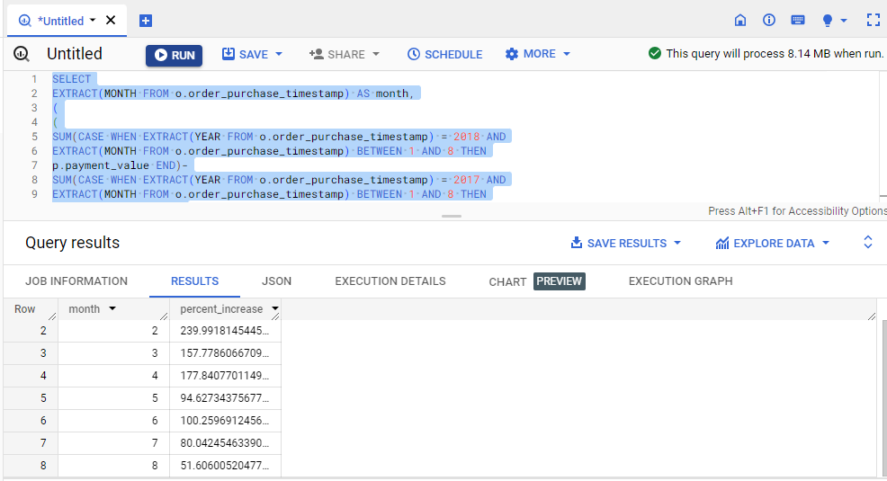

**INSIGHT:** This SQL query calculates the percentage of increase in the cost of orders from the year 2017 to 2018, and mainly for the months from January to August.  
  
**RECOMMENDATION:** This recommendation helps us understand the growth rate of order costs during this specific period.  
  
  
**ASSUMPTION:** Assumption made here is that compare between 2017 and 2018 there is increase in percentage of cost of orders

**2.Calculate the Total & Average value of order price for each state.**

**Query:**

select cus.customer_state,

avg(oi.price) as Average_price, sum(oi.price) as Total_price

from `Target.orders` ord join  `Target.order_items` oi

on ord.order_id=oi.order_id

join `Target.customers` cus on ord.customer_id=cus.customer_id

group by cus.customer_state;

SS:

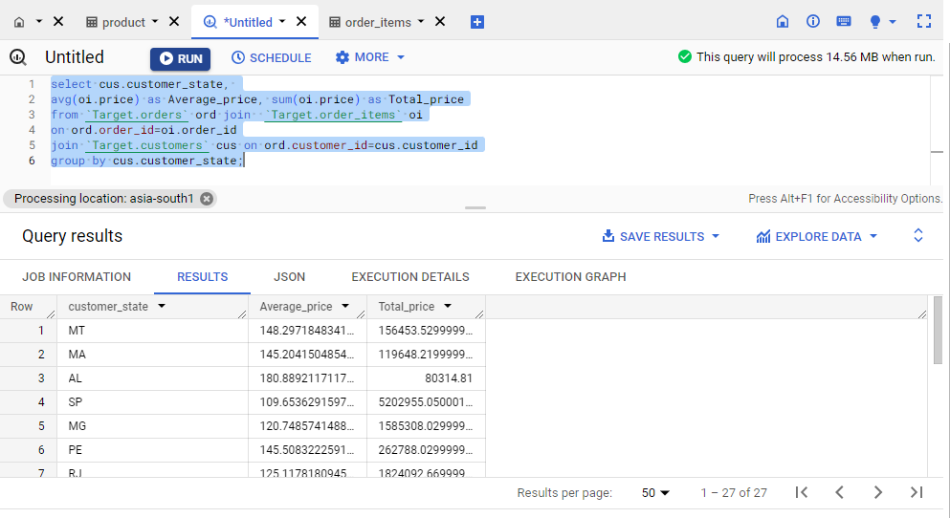

**INSIGHT:** It gives the total and average order prices for each state.  
  
**RECOMMENDATION:** It easily gives the total order prices and average order prices of thr each and every state and provides a breakdown of the financial performance in each state, offering an understanding of the total revenue generated and the average value of orders placed by customers in different states.  
  
**ASSUMPTION:** Assumption made here is that we can identify the average customer order in the particular state and if there is any lower state, we can come with some business strategies.

**3.Calculate the Total & Average value of order freight for each state.**

**Query:**

select cus.customer_state,

avg(oi.freight_value) as Average_freight_value, sum(oi.freight_value) as Total_freight_value

from `Target.orders` ord join  `Target.order_items` oi

on ord.order_id=oi.order_id

join `Target.customers` cus on ord.customer_id=cus.customer_id

group by cus.customer_state;

SS:

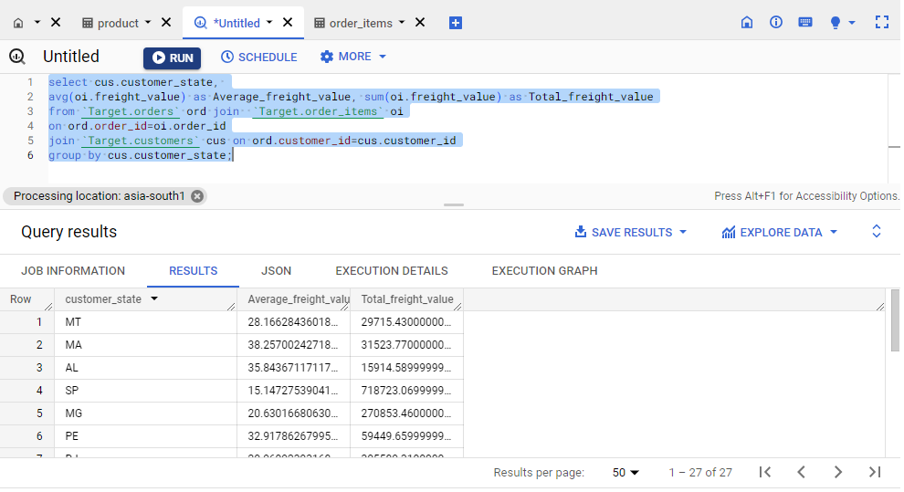

**INSIGHT:** The SQL query calculates the total and average order freight for each state.  
  
**RECOMMENDATION:** It helps us understand the growth rate of order freight during this specific period.  
  
**ASSUMPTION:** Assumption made here is that we can identify the average customer freight in the particular state and if there is any lower state, we can come with some business strategies.

**5.Analysis based on sales, freight and delivery time.**

**1.Find the no. of days taken to deliver each order from the order’s purchase date as delivery time.  
Also, calculate the difference (in days) between the estimated & actual delivery date of an order.  
Do this in a single query.  
  
You can calculate the delivery time and the difference between the estimated & actual delivery date using the given formula:**

* + - **time_to_deliver = order_delivered_customer_date - order_purchase_timestamp**
    - **diff_estimated_delivery = order_estimated_delivery_date - order_delivered_customer_date**

**Query:**

SELECT

order_id,

date_diff(order_delivered_customer_date, order_purchase_timestamp, DAY)

as order_delivered_in_days,

date_diff(order_estimated_delivery_date, order_purchase_timestamp, DAY)

as order_estimated_delivery_in_days,

date_diff(order_estimated_delivery_date, order_delivered_customer_date, DAY)

as difference_between_estimated_and_actual_delivery_days

FROM

`Target.orders`

WHERE

DATE_DIFF(order_delivered_customer_date, order_purchase_timestamp, DAY) is NOT NULL

ORDER BY

order_delivered_in_days;

SS:

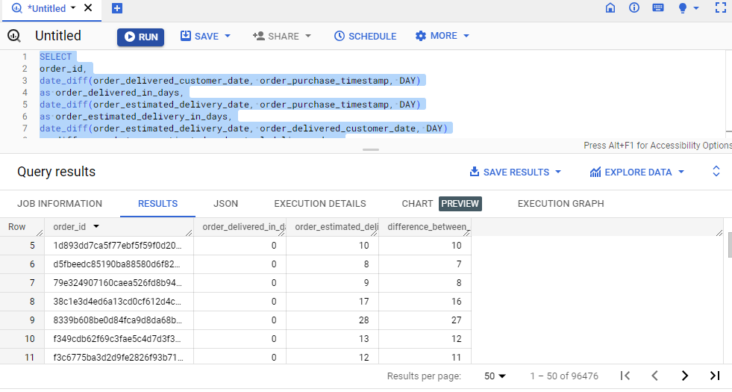

**INSIGHT:** The provided SQL query calculates the delivery time for each and every order, that is the number of days taken to deliver the order from the purchased date  
  
**RECOMMENDATION:** It will gives us the delivery time of the order, so in future we can improve delivery time on the cities/states where we lag. So it gives the good impact on our customers.  
  
**ASSUMPTION:** Assumption made here is that we can identify products that are delivered to the customer on time or whether we need to improve the standard deliver to make customer happy.

**2.Find out the top 5 states with the highest & lowest average freight value.**

**Lowest 5:**

**Query:**

select cus.customer_state,

avg(oi.freight_value) as Average_freight_value, sum(oi.freight_value) as Total_freight_value

from `Target.orders` ord join  `Target.order_items` oi

on ord.order_id=oi.order_id

join `Target.customers` cus on ord.customer_id=cus.customer_id

group by cus.customer_state

order by Average_freight_value asc

limit 5;

SS:

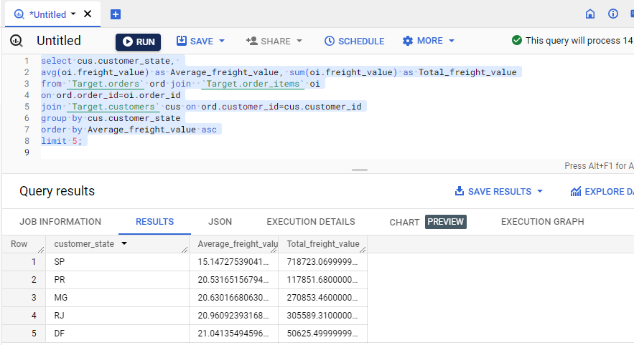

**Highest 5:**

**Query:**

select cus.customer_state,

avg(oi.freight_value) as Average_freight_value, sum(oi.freight_value) as Total_freight_value

from `Target.orders` ord join  `Target.order_items` oi

on ord.order_id=oi.order_id

join `Target.customers` cus on ord.customer_id=cus.customer_id

group by cus.customer_state

order by Average_freight_value desc

limit 5;

SS:

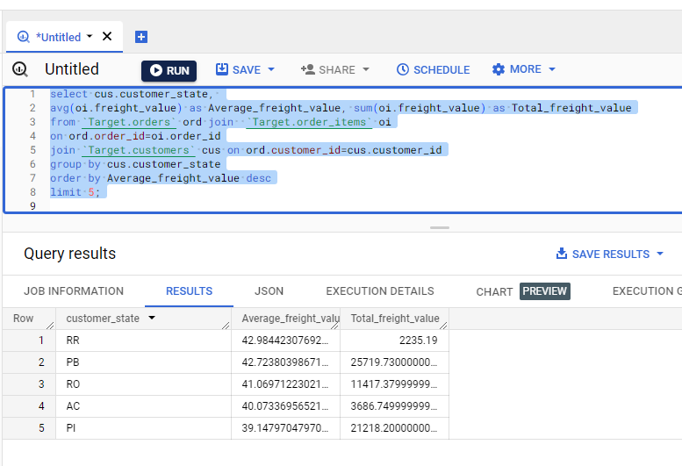

**INSIGHT:** The query calculates the average and total freight values for each state and presents the top 5 states with the highest and lowest average freight values.  
  
**RECOMMENDATION:** In order to this we need to focus more on the lowest average freight values of the states to increase our customer base.  
  
**ASSUMPTION:** Assumption made here is that we can identify the highest freight on the each state to decision in business level.

**3.Find out the top 5 states with the highest & lowest average delivery time.**

**Lowest:**

**Query:**

select

cus.customer_state,

avg(date_diff(order_estimated_delivery_date, order_purchase_timestamp, DAY)) as Average_time

from `Target.orders` ord join `Target.customers` cus

on ord.customer_id = cus.customer_id

where

date_diff(order_delivered_customer_date, order_purchase_timestamp, DAY) is NOT NULL

GROUP BY cus.customer_state

ORDER BY average_time asc

limit 5

SS:

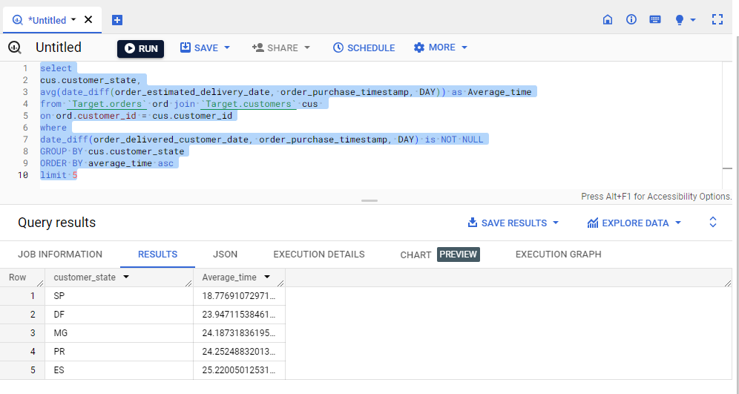

**Highest:**

**Query:**

select

cus.customer_state,

avg(date_diff(order_estimated_delivery_date, order_purchase_timestamp, DAY)) as Average_time

from `Target.orders` ord join `Target.customers` cus

on ord.customer_id = cus.customer_id

where

date_diff(order_delivered_customer_date, order_purchase_timestamp, DAY) is NOT NULL

GROUP BY cus.customer_state

ORDER BY average_time desc

limit 5

SS:

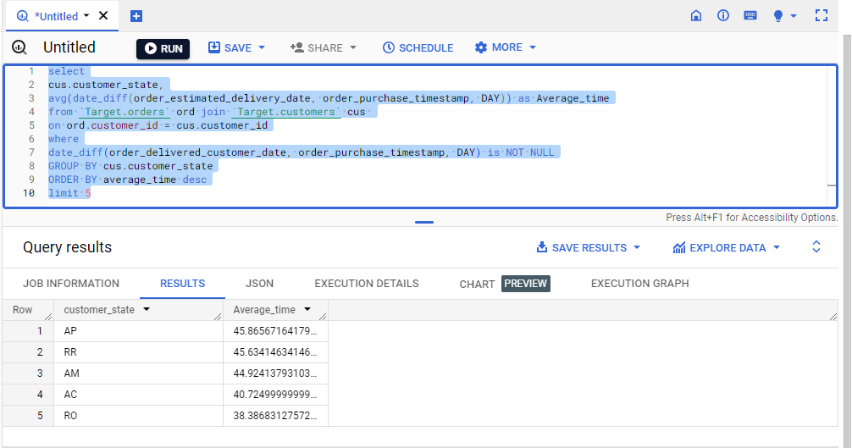

**INSIGHT:** It calculates the average and total freight values for each state and presents the top 5 states with the highest and lowest average delivery time.  
  
**RECOMMENDATION:** It helps us to understand on which state our order delivery time takes more days to deliver to the customers, take some steps to reduce the delivery time  
  
  
**ASSUMPTION:** Assumption made here is that we can identify the quickest delivery time on the each state to take decision in business level to improve the same.

**4.Find out the top 5 states where the order delivery is really fast as compared to the estimated date of delivery.  
You can use the difference between the averages of actual & estimated delivery date to figure out how fast the delivery was for each state.**

**Query:**

select

cus.customer_state,

round(avg(date_diff(order_delivered_customer_date, order_purchase_timestamp, DAY)), 2)

as avg_time_to_delivery,

round(avg(date_diff(order_estimated_delivery_date, order_delivered_customer_date, DAY)), 2)

as avg_diff_estimated_delivery

from

`Target.orders` ord join

`Target.customers` cus on

ord.customer_id = cus.customer_id

where

date_diff(order_purchase_timestamp, order_delivered_customer_date, DAY) is NOT NULL

and

date_diff(order_estimated_delivery_date, order_delivered_customer_date, DAY) is NOT NULL

group by

cus.customer_state

order by

avg_time_to_delivery desc, avg_diff_estimated_delivery desc

limit 5

SS:

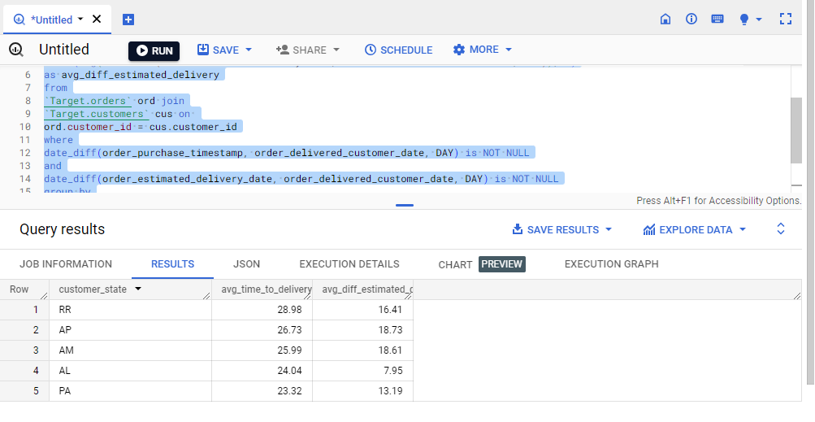

**INSIGHT:** The provided SQL query calculates the average time taken for order delivery and the average difference between the actual and estimated delivery time for each state  
  
**RECOMMENDATION:** The results identify the top 5 states where the order delivery is notably faster than the estimated delivery date. So we need to deliver them still more fast will give the big impact on our customers and also increase the customer base.  
  
**ASSUMPTION:** Assumption made here is that we can identify conducting customer satisfaction surveys in these states can provide insights into the reasons behind the positive delivery experience and help in identifying areas for further improvement.

**6.Analysis based on the payments:**

**1.Find the month on month no. of orders placed using different payment types.**

**Query:**

SELECT

pay.payment_type,

EXTRACT(MONTH FROM ord.order_purchase_timestamp) AS month,

COUNT(DISTINCT ord.order_id) AS order_count

FROM `Target.payments` pay

JOIN `Target.orders`ord ON pay.order_id=ord.order_id

GROUP BY pay.payment_type,month

ORDER BY pay.payment_type,month;

SS:

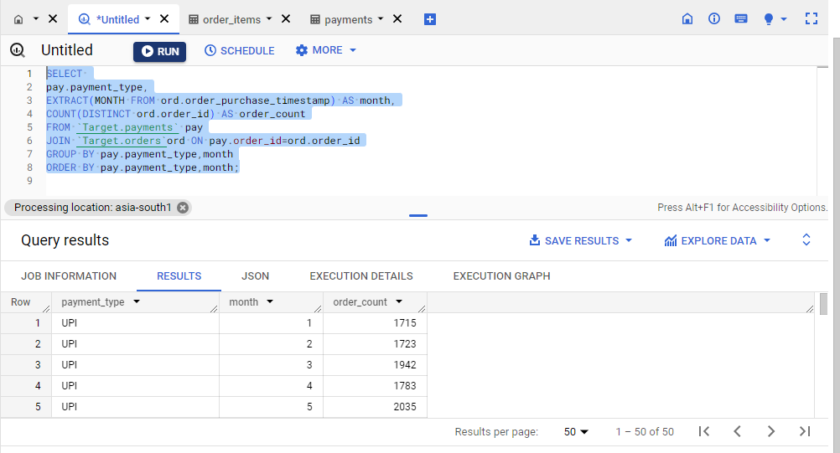

**INSIGHT:** The provided SQL query analyzes the number of orders placed using different payment types on a month over month basis.  
  
**RECOMMENDATION:** By using this information we need to optimize the payment processing methods and also give some offer promotions or incentives for using certain payment types, and improve overall payment options to meet customer preferences.  
  
**ASSUMPTION:** Assumption made here is that we can identify the customer with the payment mode normally used to purchase the products, mostly UPI payments are followed.

**2.Find the no. of orders placed on the basis of the payment installments that have been paid.**

**Query:**

SELECT

pay.payment_installments,

COUNT(ord.order_id) AS order_count

FROM `Target.payments` pay

JOIN `Target.orders`ord ON pay.order_id=ord.order_id

GROUP BY pay.payment_installments

ORDER BY pay.payment_installments;

SS:

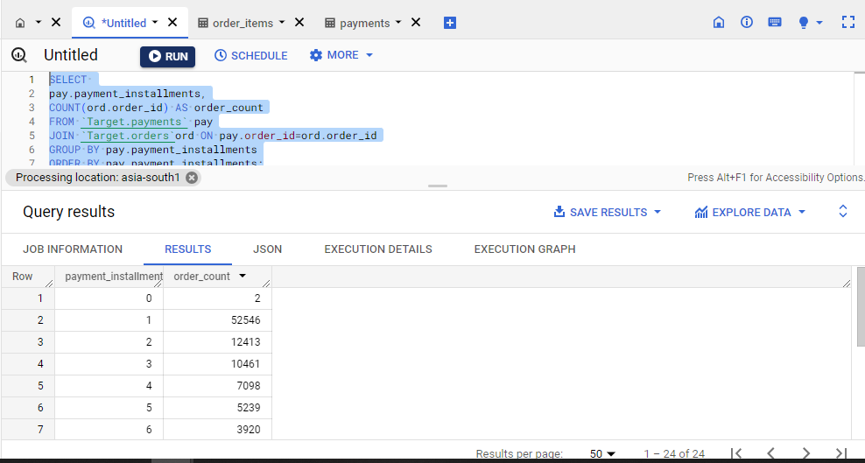

**INSIGHT:** The provided SQL query analyzes the number of orders placed on the basis of the payment installments method that have been paid  
  
**RECOMMENDATION:** We can use this information to made their payment options, also provide more flexible installment plans, and better accommodate customer preferences.  
  
**ASSUMPTION:** Assumption made here is that we can identify the customer are mostly preferred with installments, so that we can provide offers based on the scenario.